SAVE THE DATE—DECEMBER 12, 2020

THE ANNUAL “CHRISTMAS IN HISTORIC MONTGOMERY”

Where the Holidays Begin!

By Bea Rouse
936.524.054
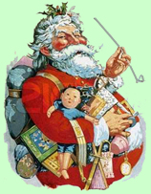
Montgomery County’s oldest Christmas celebration has activities not found anywhere else in the area. Do not miss this wonderful day full of events to create memories and fun for every family member, in downtown Historic Montgomery, one of Texas’ oldest towns—the birthplace of the Texas flag.
The Montgomery Historical Society, founded in the 1950s, produces the Society’s only fundraising event, with proceeds going toward maintaining the seven historic buildings owned by the Society.
The strolling carolers, residents in period dress, coupled with the old-fashioned decorations in the historic buildings on the tour, will make you feel you have stepped back to the mid-1800’s when Montgomery was the county seat.
The City of Montgomery is sponsoring the parade which begins at an earlier time this year: 9:00 a.m. It will start on Liberty St. and head north across Eva St., then will wind through the downtown historic area. For safety reasons, no candy is allowed to be thrown from the floats—parade walkers will hand out wet to the crowds. (The deadline has passed to apply to be in the parade.) City Hall: 936.597.6434.
Vendors—sign up soon for booths at the Holiday Marketplace Arts & Crafts. Items must be homemade or homegrown. This is a great opportunity for visitors to find Christmas gifts and holiday décor. Booths are 10’x10’, renting for $85, or $115 with electricity. For more information, visit www.facebook.com/MontgomeryTexasHistoricalSociety where you can print an application. Contact Bea at brouse0122@aol.com for more information. The booth area this year includes some spacing to allow for some social distancing for vendors and visitors. In addition to the grounds around the Montgomery Community Building, spaces will be available on the vacant lots adjacent to the N. H. Davis Complex & Museum at Eva and Liberty Streets (SH 105 and FM 149).
The community, and especially the Montgomery Independent School District, fully support this popular and remarkable event by sponsoring specific aspects from the many school and civic groups participating in the parade to providing festive cookies and candies for the Famous Cookie Walk. This year marks the 30th Annual Cookie Walk, which was created by the late, wonderful lady, Reba Laughter. This event was featured in the 1999 issue of Southern Living magazine!
The Society is grateful to the Montgomery Monarchs Chapter of the National Charity League for continuing the incredibly difficult task of staging and serving the thousands of convections. Visitors pay by the pound for their boxes of decorative sweets. NOTE: The Community Building doors will open earlier this year—10 a.m—and will remain open until 5 p.m. …or until all the cookies and candies are sold! Folks line up long before the doors open to be the first ones in this popular feature of Montgomery’s Christmas event.
The Montgomery County Health Department has approved the plans to adhere to the CDC recommendations for public safety at community events. All cookies and candies will be completely wrapped, the NCL mothers and daughters will be masked and gloved, and gloves will be given to the shoppers and the number of people inside the building to be limited to safe numbers. Masks will be mandatory.
The 42nd Annual Candlelight Tour, from 4pm to 8pm, rounds out the day as visitors get to experience some of the historic buildings hosted by volunteers in period dress. On the tour this year are the seven buildings owned by the Society, the Living Savior Lutheran Church chapel built in 1908, The Oaks of Montgomery Antiques, plus one private home. (For the public and safety of the homeowners, most of the private homes will not be on the tour this year.)
Montgomery’s Fernland Historical Park will be open for tours until 3:00 p.m. However, the park’s anchor building, the Society-owned Arnold-Simonton Home, will remain open for the evening tour. Tour tickets are $5 for students/children, $15 for adults, and can be purchased at the N.H. Davis Complex & Museum beginning at 2:00 p.m., or all day at Rustic Cashmere shop, both on Liberty Street.
The Madrigals, carolers from Montgomery High School, will add to the holiday cheer strolling throughout the historic district. In addition to the restaurants’ extended hours, there will be vendors offering food, snacks, beverages, AND the many antique/gift shop, boutiques and specialty shops will also have extended hours.
While in town for this yearly event and throughout the holiday season, visitors can "Think Small" and shop inmontgomerytxhistoricalsociety@gmail.com Historic Montgomery for great gifts at small-town prices.
The Montgomery Historical Society thanks all participants and visitors for your support.
Funds generated from this event goes toward the PRESERVATION
and MAINTENANCE of properties owned by the Society.
montgomerytxhistoricalsociety@gmail.com
P. O. Box 513 ~ Montgomery, TX 77356
N. H. Davis Museum: 936.697.4360

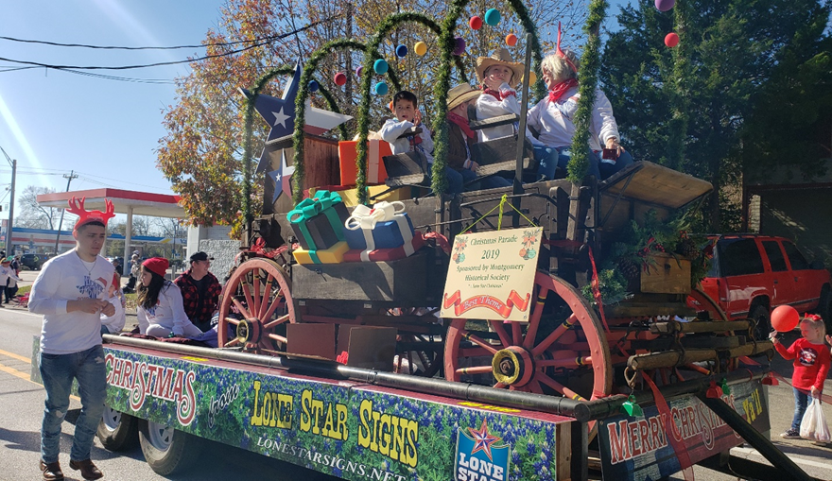
2019 Parade Winner ~ "Best Theme"

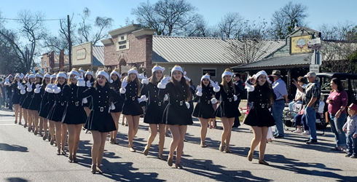
The Lake Creek Royals in the 2019 Parade

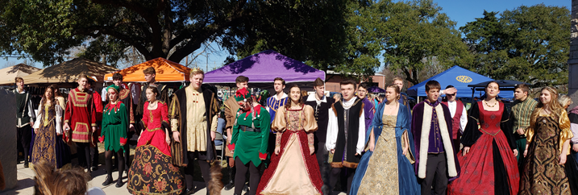

The strolling Madrigals, Montgomery High School Students

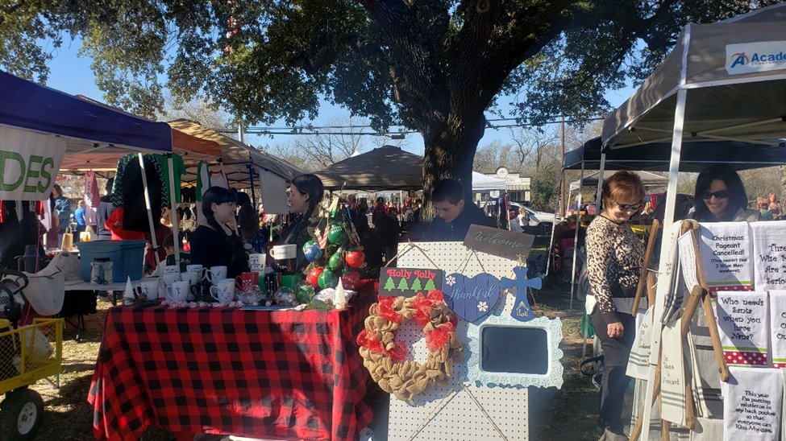
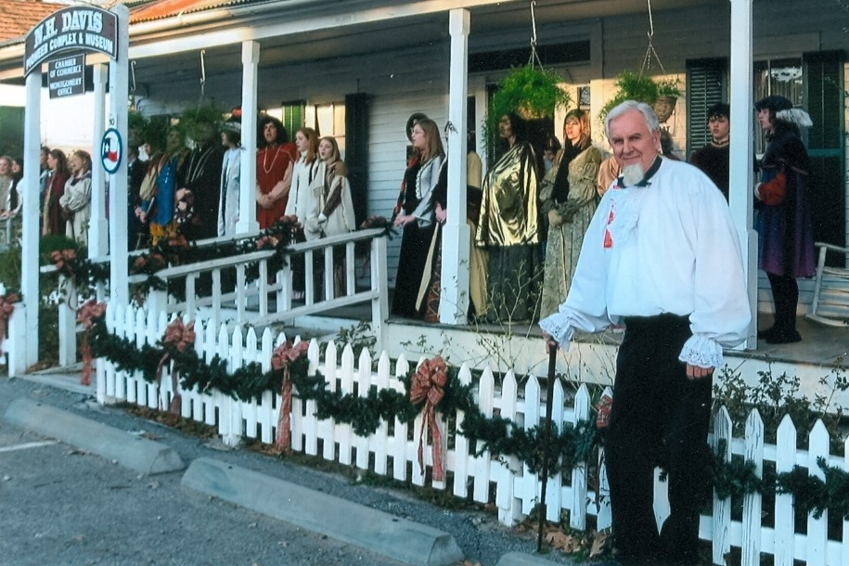
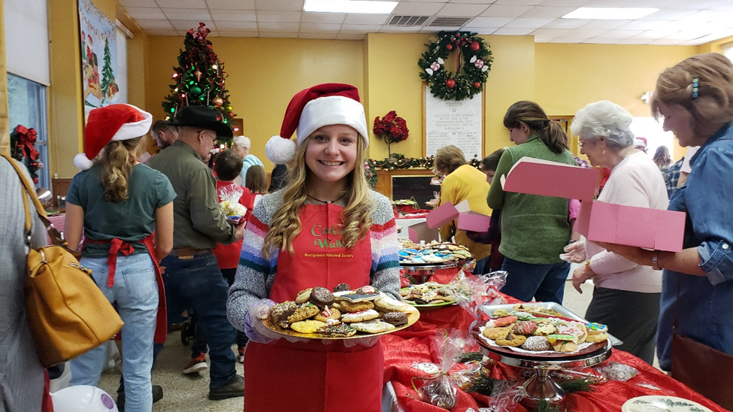
Jack Shepherd portrays Dr. Charles B. Stewart, Designer of the Lone Star Flag
The Montgomery Monarchs National Charity League work at the Cookie Walk

